Name: Jamie Anthony Brindle
Student ID: 06352322
Title: Website Development: Online Bookshop Assignment 1 Demonstration and Testing
Introduction, Booksearch & Welcome Pages

Index Page: Introduction
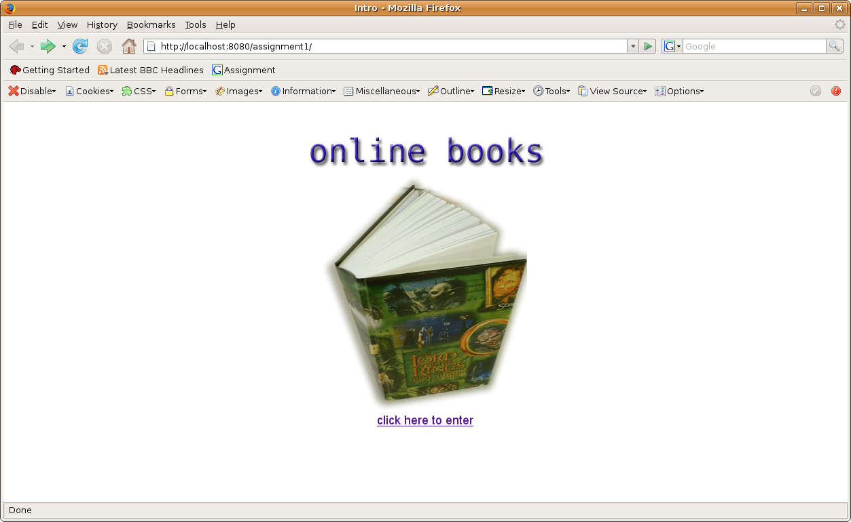
Simple introduction page, also seeing if tomcat is up and running.

Welcome Page: User never visited site before
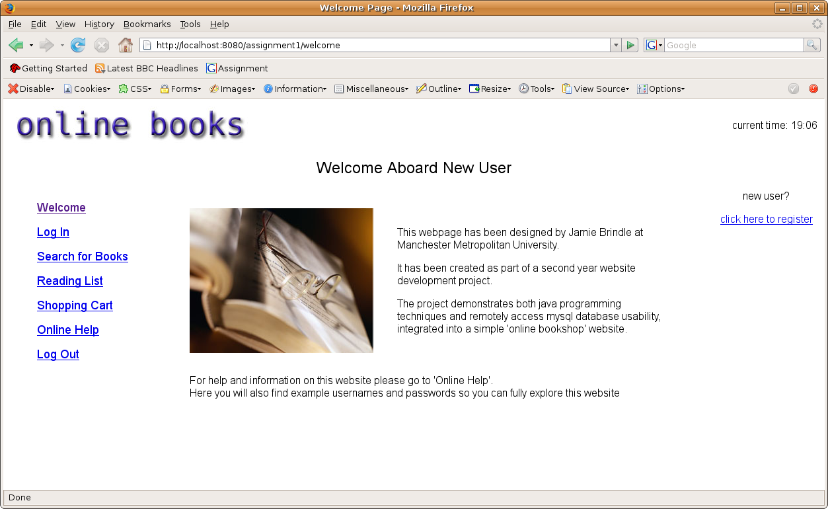
welcome or 'home' page. There is no cookie on file so welcome page things user is new to the site and displays a particular message, and also displays current time
Welcome Page: User Visited Site Before
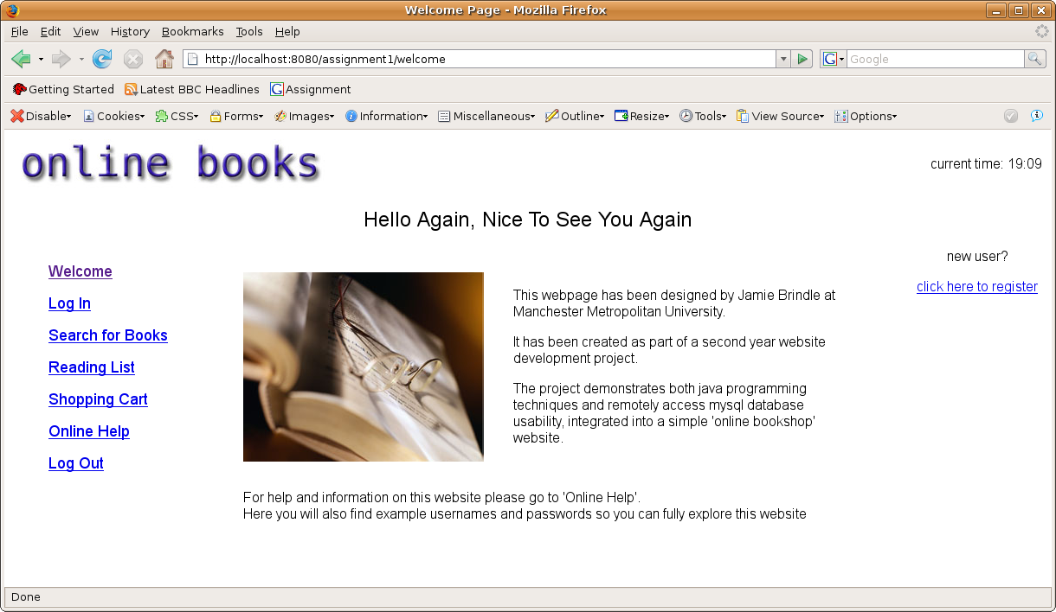
Welcome page has a long term cookie on file so knows user visited before and displays 1 of 7 welcome back messages

Search for Books Page:
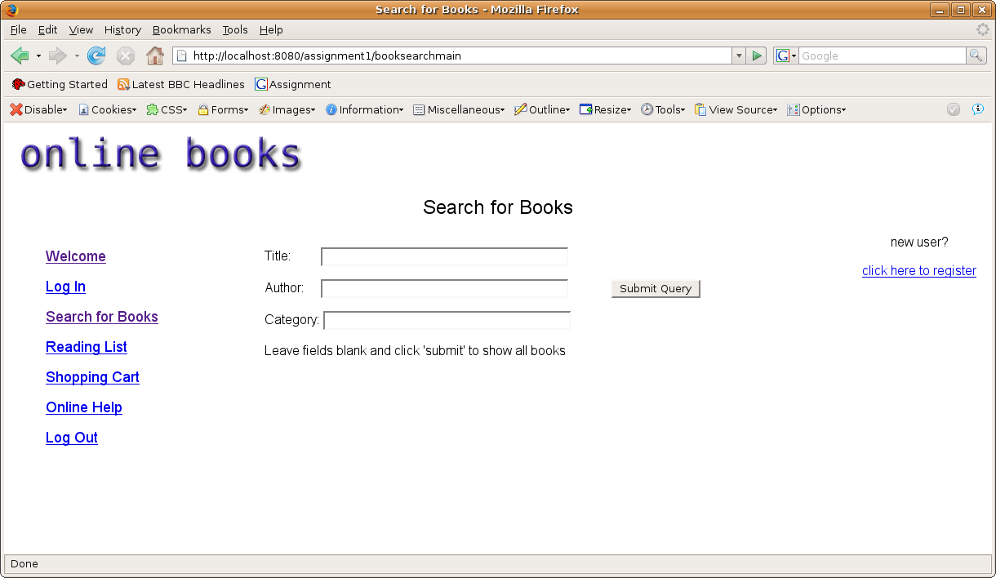
Simple book search page, user can enter details of 3 different types and doesn't have to put the whole detail of the book, and can search with no fields entered to view all books

Booksearch Results: Details entered on title: java
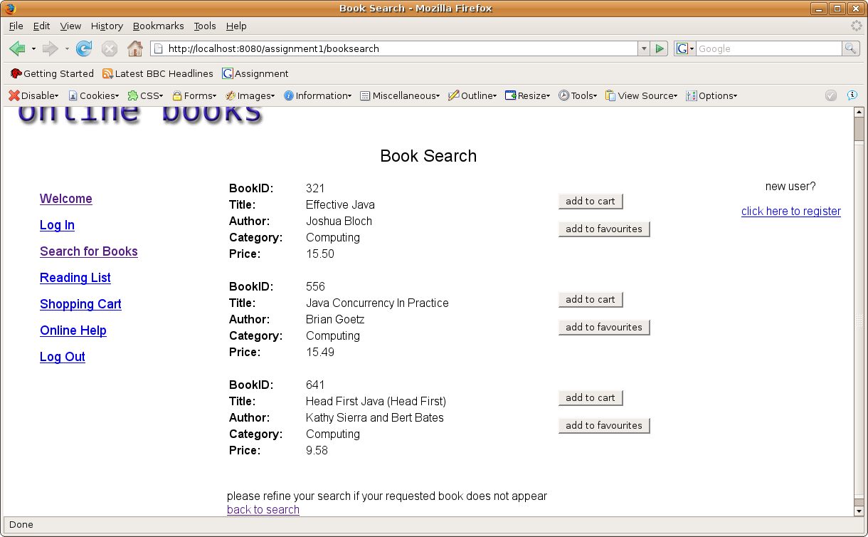
3 books are returned with 'java' included in the title

Booksearch Results: Details entered on title: java and author: brian
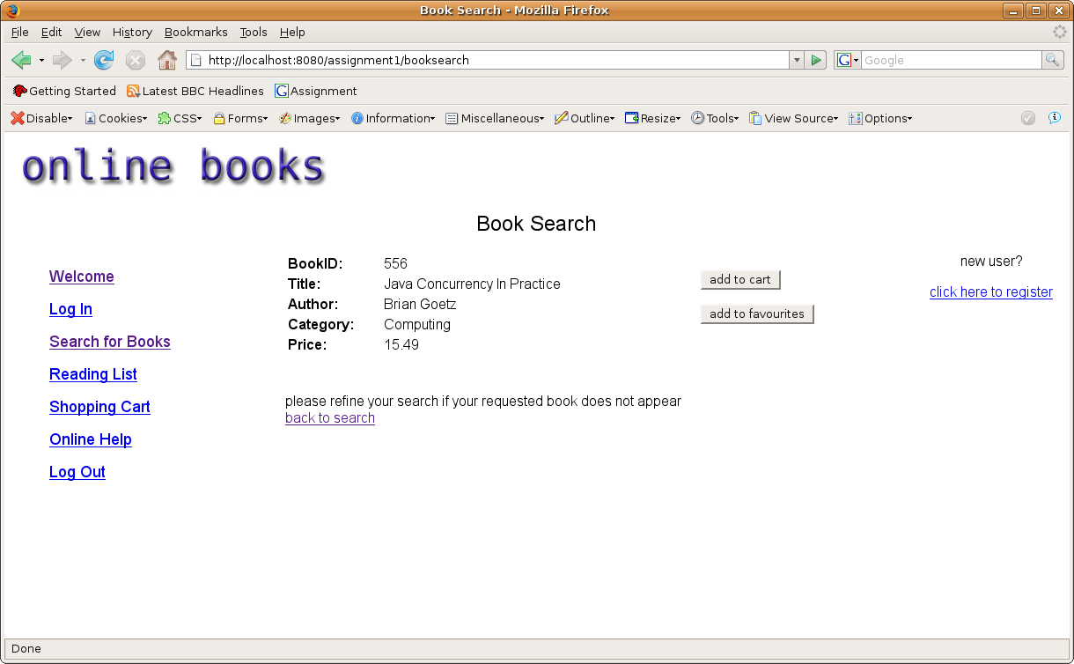
1 book returned as expected

Booksearch: No details entered:
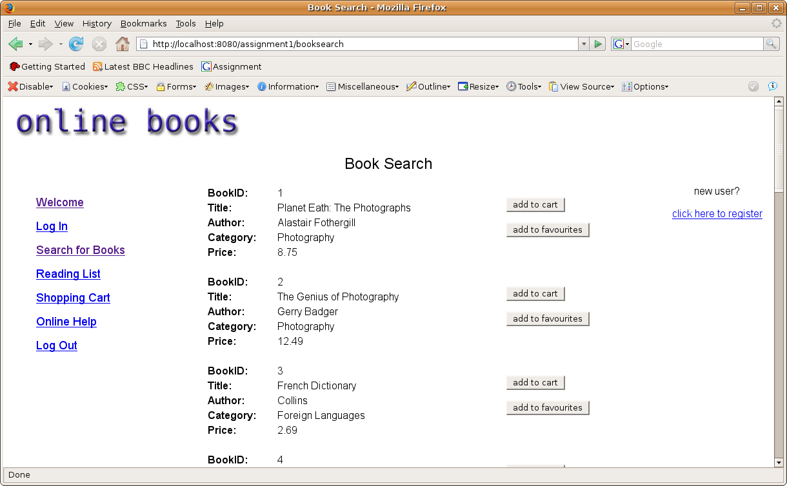
All books returned as expected

Booksearch: Fields entered that can't possibly have a result
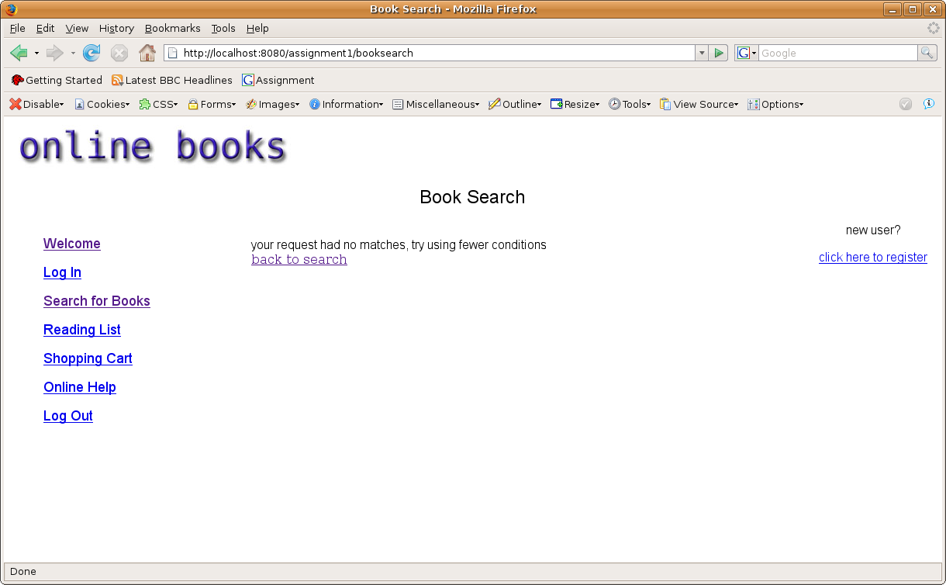
No books returned as expected

